VIETNAM NATIONAL UNIVERSITY
TRƯỜNG QUỐC TẾ
VNU – INTERNATIONAL SCHOOL



Module: INS3254 – Introduction to Data Science
FINAL TEAM PROJECT DESCRIPTION

TOPIC: Red Wine Classification using SVM

Group 8:
Nguyễn Thái Hoài An
Đào Thị Phương Anh 22070895
Nguyễn Tú Anh
Nguyễn Quỳnh Chi
9th January, 2025
INTRODUCTION
The project with the theme “Data Science” with the topic “Red Wine Clasification using SVM” is the result of a course and the efforts and coordination of all members of our group 8. And this report is both a mark and a record for our efforts over the past time. During the process of implementing and completing this project, we received enthusiastic guidance and help from teachers and friends. We would like to send our sincerest and deepest thanks to the teachers and staff in the Faculty who dedicatedly taught and imparted the necessary knowledge during our time studying at VNU-IS so that we I have enough knowledge, experience and confidence to complete this project.
In particular, we would like to thank Mr. Truong Cong Doan, who dedicatedly guided, instructed, and supported us throughout the implementation of this project. During the time of studying and working with him, we not only learn about specialized knowledge but also about a serious working attitude and how to cooperate in work to complete the job effectively. best. Although we have tried to complete the exercises within our scope and ability, there are certainly shortcomings. I respectfully hope to receive the sympathy as well as suggestions from teachers and friends. Finally, I would like to wish teachers good health and always be the leaders of generations of students. VNU-IS matures and becomes an important factor in the labor market.
Sincerely thanks!

Table of contents
I. Introduction
II. Methodology
- Importing Library
- Loading dataset
- Checking for Null, Missing Values
- Visualizing the whole dataset
III. Model
IV. Result
V. Conclusion
VI. Member’s Contribution

II. Methodology
- Importing Library
Import library to provides neecessary tools for data manipulaton, analysis, and modeling.
import pandas as pd
import numpy as np
import matplotlib.pyplot as plt
import seaborn as sns
import plotly.graph_objects as go
from sklearn.preprocessing import StandardScaler
scaler=StandardScaler()
from sklearn.metrics import confusion_matrix,accuracy_score,precision_score,recall_score

- Loading dataset
data_import=pd.read_csv('D:\winequality-red.csv')

Uses the read_csv function from the pandas library to read data from the winequality-red.csv file and stores it in the data_import variable as a DataFrame. A DataFrame is a table-like data structure that makes it easy to manipulate and analyze the data.

# Printing whole dataset
data_import
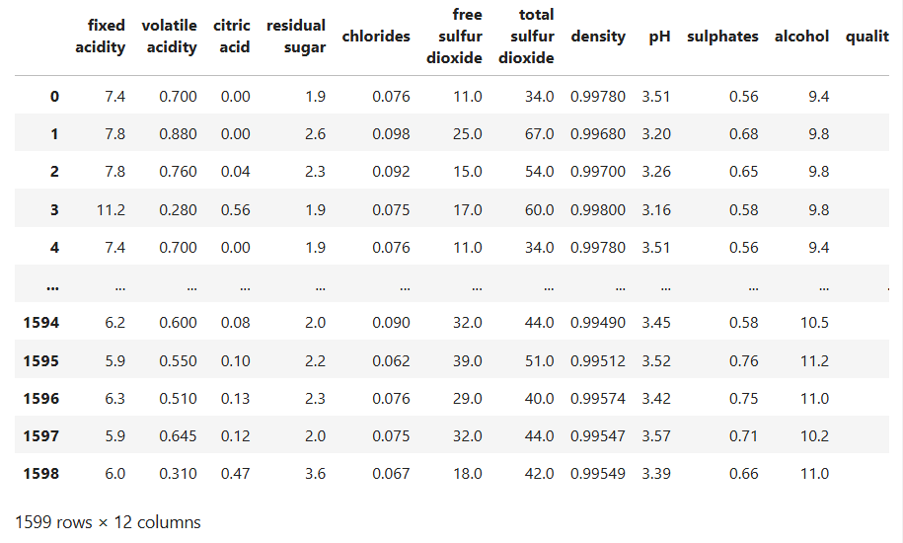
# Printing the Total Row and Column using Shape
data_import.shape
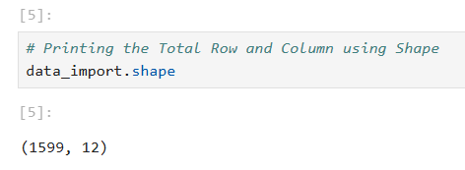
# Printing First Five Rows of dataset using head()
data_import.head()
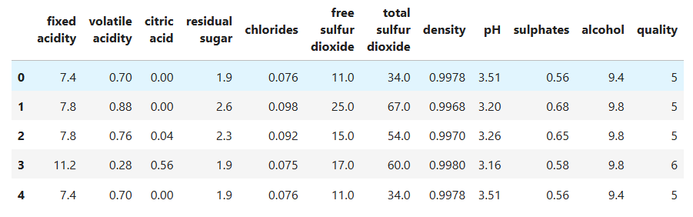
# Printing Last Five Row of Dataset using tail()
data_import.tail()
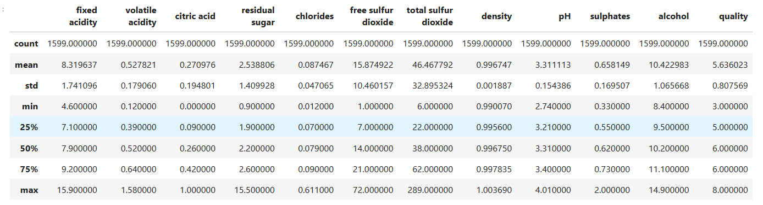

# info(): prints information about a DataFrame including the index dtype
# and column dtypes, non-null values
data_import.info()
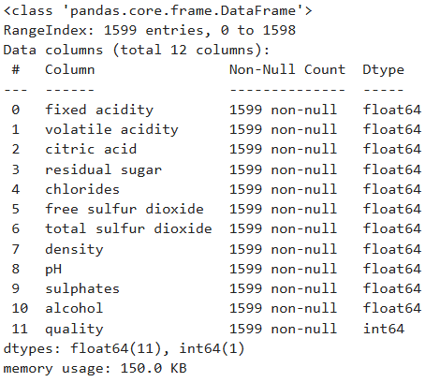
# describe() : is used to view some basic statistical details like
# percentile,mean, std, etc

data_import.describe()
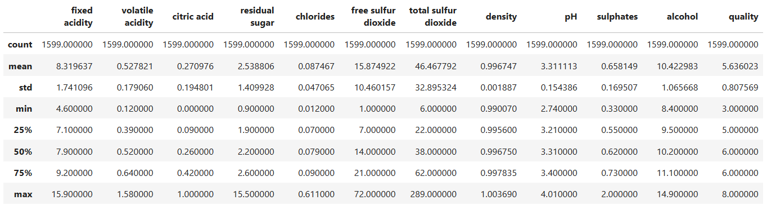

=> Load dataset to brings the data into the program, enabling you to analyze and build models on it.

- Checking for Null, Missing Values
Purpose: Checking for missing values helps ensure the integrity and reliability of your analysis and model.

data_import.isnull().sum()

Checking for missing values helps ensure the integrity and reliability of your analysis and model.
#Missing value
import pandas as pd

# Đọc dữ liệu
data = pd.read_csv('D:\winequality-red.csv')

# Điền giá trị trung vị vào các ô trống trong toàn bộ DataFrame
data.fillna(data.median(), inplace=True)

# In ra DataFrame sau khi đã xử lý
print(data)

import pandas as pd: pandas is a library in Python, used to work with tabular data (DataFrames). Here, the library is imported with the alias pd for ease of use in the following commands.
pd.read_csv(): This function is used to read data from a CSV file and convert the data into a DataFrame (a 2-dimensional tabular data structure in pandas).
data.median(): Calculates the median value for each column in the DataFrame. The median is the value in the middle when all the values ​​in a column are sorted in ascending order.
data.fillna(): Replaces all NaN values ​​(blank cells or missing values) with the specified value. Here, data.median() will replace all blank cells with the median of each corresponding column.
inplace=True: Updates the DataFrame data directly without creating a new copy. Purpose: Handle missing values ​​in data to avoid affecting analysis or models.

print(data.isnull().sum().sum())
# In ra dataframe để kiểm tra kết quả
print("\nDataframe sau khi xử lý:\n")
print(data.head())

# Handling duplicate
# Đọc dữ liệu từ file CSV
data = pd.read_csv('winequality-redd.csv')

# Lấp đầy các giá trị thiếu bằng ffill() và bfill()
data = data.ffill().bfill()

# In ra số lượng giá trị null còn lại trong mỗi cột
print("Số lượng giá trị null sau khi lấp đầy:\n")
print(data.isnull().sum())

# In ra dataframe để kiểm tra kết quả
print("\nDataframe sau khi xử lý:\n")
print(data.head())

# Lọc các hàng bị trùng (giữ các hàng xuất hiện nhiều hơn một lần)
duplicate_rows = data[data.duplicated()]

# In ra các hàng trùng nhau
print("Các hàng trùng nhau:")
print(duplicate_rows)
- Visualizing the whole dataset
#Tính ma trận tương quan giữa các cột số liệu.
corr = data_import[data_import.columns].corr()
#Vẽ heatmap
sns.heatmap(corr, cmap="YlGnBu", annot = True)
#Đặt tiêu đề cho biểu đồ
plt.title('Heatmap for Correlation of Parameters')
#Hiển thị biểu đồ
plt.show()

#Vẽ heatmap với:
cmap="YlGnBu": Bảng màu vàng-xanh.
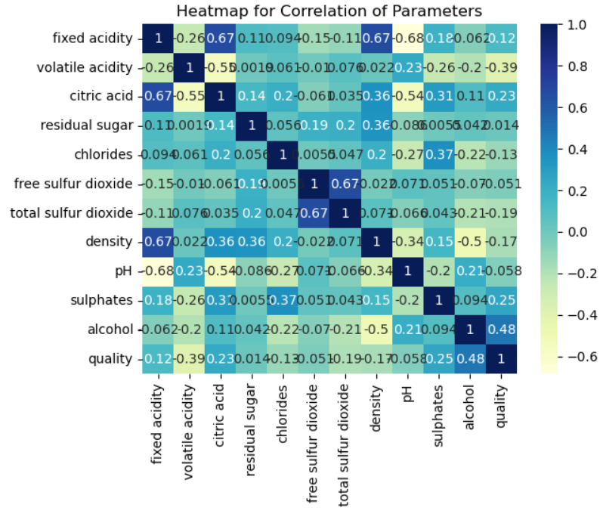
annot=True: Hiển thị giá trị tương quan trên từng ô.

# PLotting Histogram for whole dataset using hist()
data_import.hist(figsize=(17,12),color='Pink')
plt.show() #Hiển thị biểu đồ

Đoạn code này dùng để vẽ biểu đồ histogram cho toàn bộ dataset nhằm hiểu rõ phân bố của từng cột trong dữ liệu.

hist(): Phương thức của Pandas dùng để vẽ histogram cho tất cả các cột có kiểu dữ liệu số trong DataFrame.
figsize=(17,12): Đặt kích thước của biểu đồ (rộng 17, cao 12) để biểu đồ rõ ràng và dễ nhìn hơn.
color='Pink': Đặt màu sắc của các cột histogram là màu hồng.

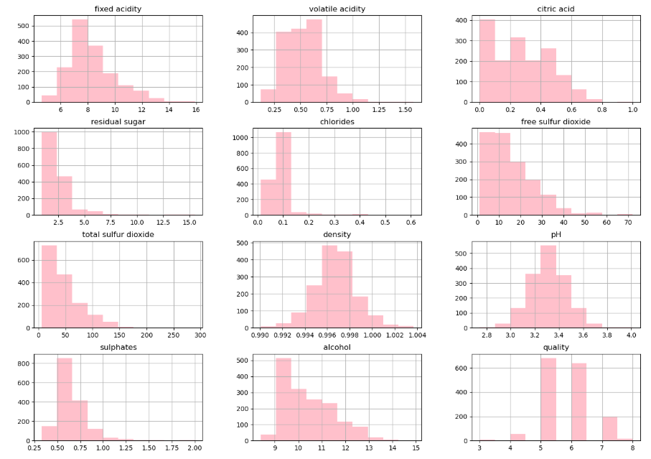

III. MODELING
1.Prepare data for fitting
# So changing quality value to True or False Based on if a wine has quality value over 5
#(if quality > 5 its is a good wine or else its False)

y=data_import['quality']>5
y

• y = data_import['quality']: Accesses the 'quality' column in the DataFrame data_import, which contains the quality scores of the wine.
• Compares each value in the column to 5. This creates a Boolean series (True or False):
- True if the 'quality' value is greater than 5.
- False if the 'quality' value is less than or equal to 5.
• y: Is a pandas Series containing True or False values, with the same number of rows as data_import. => Classifies the wine into two categories:
- True: Wine of good quality (quality > 5).
- False: Wine of not good quality (quality <= 5).

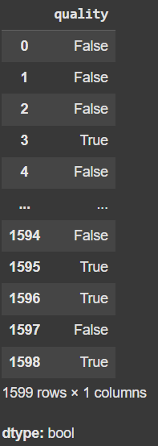

# Removing Target Variable i.e Quality

X=data_import.iloc[:,:-1]

X

• Removing the target column quality from the DataFrame data_import to create a new DataFrame X, containing all feature columns except the last one (target variable).
• data_import.iloc[:,:-1]:
- iloc is a method of pandas DataFrame used to select elements by row and column positions (index starting from 0).
- : (before the comma): Selects all rows.
- :-1 (after the comma): Selects all columns except the last column.
- The last column (-1) is the quality column, which is removed from the dataset.
- The remaining columns are the features that you will use to train the model.
• X:
- Is a DataFrame containing all feature columns except the last column (quality).
- The variable X is commonly used as the input dataset (features) for machine learning models.
Main Objective:
Prepare the feature data for the machine learning task.
The quality column is the target variable, so it needs to be separated to avoid affecting the feature data.

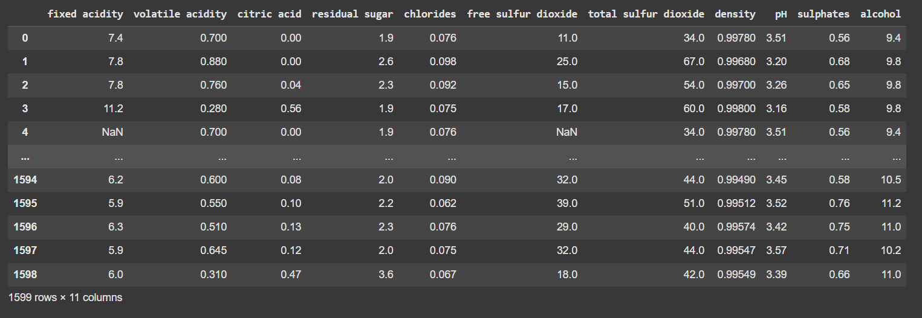

2.Splitting data into Training data and Testing data

from sklearn.model_selection import train_test_split
X_train,X_test,y_train,y_test=train_test_split(X,y,random_state=42,test_size=0.2)

X: This is the set of features (input variables) of the dataset, usually an array or DataFrame that you use to train your model.
y: This is the set of labels (target variable) that you want to predict, also an array or Series.
X_train: The training set of features. This is the portion of the data that you will use to train the model.
X_test: The testing set of features. This is the portion of the data that you will use to test the model after it has been trained.
y_train: The training set of labels. This corresponds to X_train.
y_test: The testing set of labels. This corresponds to X_test.

Parameters of the Function
test_size: The proportion or number of samples in the testing set. For example, test_size=0.2 means that 20% of the data will be used for testing, and the remaining 80% for training.
random_state: A seed used by the random number generator to ensure reproducibility. By setting this value, you get the same split each time you run the function.
X_train.shape
X_test.shape
X_train.shape: This provides the dimensions of your training set of features.
The result is a tuple where the first value represents the number of samples and the second value represents the number of features.
X_test.shape: Similarly, this provides the dimensions of your testing set of features.
The result is also a tuple where the first value represents the number of samples and the second value represents the number of features.
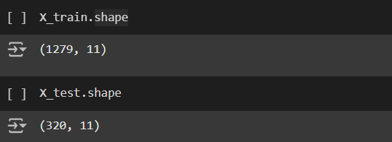

from sklearn.preprocessing import StandardScaler

scaler=StandardScaler()

scaler_X_train=scaler.fit_transform(X_train)

scaler_X_train

• from sklearn.preprocessing import StandardScaler:
Import the StandardScaler from scikit-learn.
StandardScaler is used to standardize X so that the mean is 0 and the standard deviation is 1.
• scaler = StandardScaler():
- Create a scaler object.
• scaler_X_train = scaler.fit_transform(X_train):
- fit_transform is a method of StandardScaler:
- fit: Computes the mean and standard deviation of X in X_train.
- transform: Uses the computed mean and standard deviation to standardize the data, transforming X.
- fit_transform(X_train) is a numpy array:
- Contains the standardized values of X_train.
- This array is assigned to scaler_X_train.
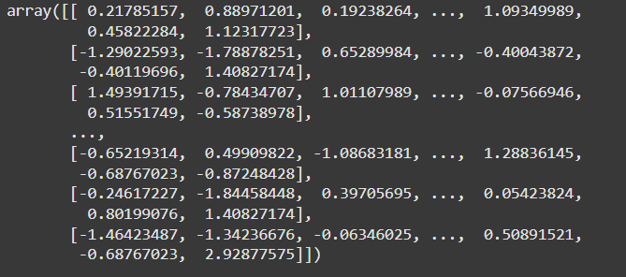

scaler_X_test=scaler.transform(X_test)

scaler_X_test

scaler_X_test

X_train.shape

scaler.transform(X_test):
transform() uses the calculated values (from X_train) to standardize the test data (X_test).
This ensures that X_test is standardized on the same scale as X_train.
scaler_X_test = scaler.transform(X_test):
X_test is standardized and the result is assigned to scaler_X_test.
scaler_X_test contains the standardized values of X_test, similar to X_train.
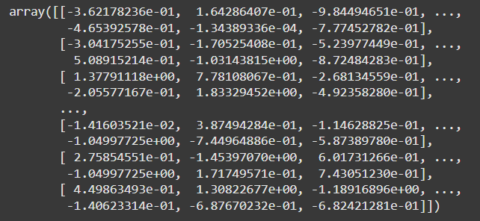
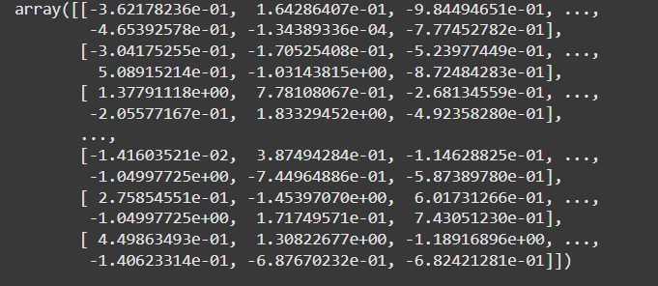
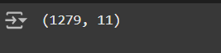

from sklearn.ensemble import RandomForestClassifier

# Giả sử X_train là dữ liệu huấn luyện và y_train là nhãn
model = RandomForestClassifier(n_estimators=100)
model.fit(X_train, y_train)

# Xem độ quan trọng của các tính năng
importances = model.feature_importances_

feature_names = X_train.columns

# In ra độ quan trọng của từng tính năng
for feature, importance in zip(feature_names, importances):
print(f'{feature}: {importance}')

from sklearn.ensemble import RandomForestClassifier:
Import RandomForestClassifier from scikit-learn.
It is a machine learning algorithm based on an ensemble of decision trees, which improves accuracy and prevents overfitting.
model = RandomForestClassifier(n_estimators=100):
Create a RandomForestClassifier model.
n_estimators=100: Specifies 100 decision trees in the forest, and this can be adjusted as needed.
model.fit(X_train, y_train):
The fit() method trains the model based on the training data.
It adjusts the model using X_train and y_train.
importances = model.feature_importances_:
The feature_importances_ attribute of the model stores the importance of each feature.
This importance indicates the influence of each feature on the model's final decision.
feature_names = X_train.columns:
Retrieve the feature names from the columns of the X_train DataFrame.
Note that this works if X_train is a pandas DataFrame; otherwise, you can provide the feature names manually.
for feature, importance in zip(feature_names, importances):
Combine the feature names and their importance using the zip function to get pairs of (feature, importance).
print(f'{feature}: {importance}'):
Print the feature names along with their importance values.

- Building SVM Classifier
This is a general algorithm for classification and regression, used to find the optimal hyperplane that separates different classes of data or predicts continuous values. When "SVM" is mentioned generally, it may refer to the overall algorithm or specific variations like SVC (Support Vector Classification) or SVR (Support Vector Regression).
=> Applying SVC to the classification problem: find an optimal hyperplane to separate data points belonging to different classes.

#Import thư viện
from sklearn.svm import SVC

#Initialize the SVM model
svc_clf = SVC(C=1.0,
kernel='rbf',
degree=3,
gamma='auto',
coef0=0.0, shrinking=True,
probability=False,
tol=0.001, cache_size=200,
class_weight=None,
verbose=False, max_iter=-1,
decision_function_shape='ovr',
break_ties=False,random_state=None)

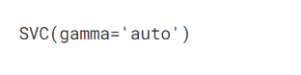
c=1.0: The parameter for regularization strength of the model. A larger value makes the model prioritize classifying each data point correctly, which can lead to overfitting. A smaller value allows the model to accept some errors, helping the model generalize better.
kernel='rbf': Specifies the type of kernel used in the SVM.
'rbf': Radial Basis Function, a popular kernel used in nonlinear problems.
degree=3: This parameter only applies to the 'poly' (polynomial) kernel. In this case, it is not relevant because the kernel used is 'rbf'.
gamma='auto': Determines the influence of a single data point on the decision boundary.
coef0=0.0: This parameter only applies to the 'poly' or 'sigmoid' kernels and does not affect the 'rbf' kernel.
shrinking=True: Enables the shrinking heuristic to speed up the optimization process.
probability=False: Does not compute probability estimates. If set to True, the model will predict probabilities, but it will be slower.
tol=0.001: The minimum error threshold for the algorithm to stop. The smaller the tolerance, the more accurate the model, but it might increase training time.
cache_size=200: The size of the cache (in MB) for storing the kernel computation.
class_weight=None: Does not adjust the weights of classes. If the data is imbalanced (minority class is significantly smaller), you can set class_weight='balanced'.
verbose=False: Does not print logs during training. If set to True, detailed logs will be displayed.
max_iter=-1: The maximum number of iterations. -1 means no limit.
decision_function_shape='ovr': Uses the "one-vs-rest" (ovr) strategy for multi-class classification problems.
break_ties=False: Does not handle ties when two classes have the same predicted probability.
random_state=None: Does not fix the randomness. This allows the model to change slightly when training on the same data.
svc_clf.fit(scaler_X_train,y_train)
scaler_X_train: The training dataset, containing features that have been standardized or preprocessed.
y_train: Labels corresponding to each data sample in the training set.
fit(): A method used to train the model with the input data and labels.
svc_clf_predictions=svc_clf.predict(scaler_X_test)

svc_clf_predictions
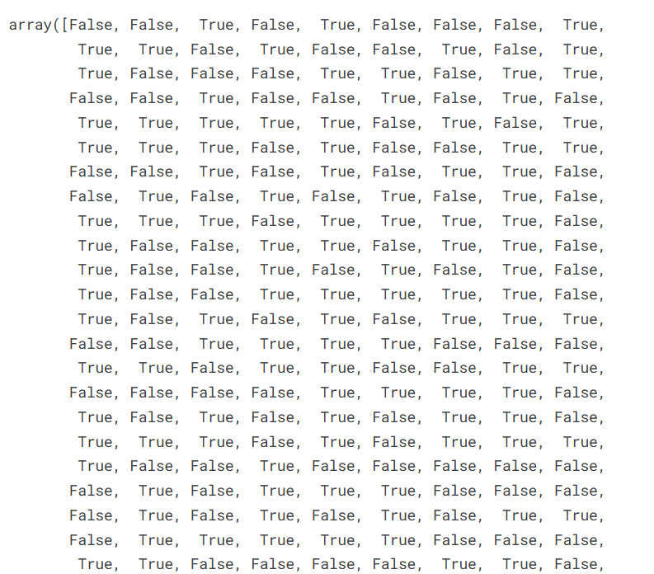
svc_clf_predictions: A variable that holds the predicted results from the model.
predict(): Predicts the labels of the data in scaler_X_test

c=confusion_matrix(y_test,svc_clf_predictions)
# Tạo ma trận nhầm lẫn để đánh giá hiệu suất của mô hình phân loại.
a=accuracy_score(y_test,svc_clf_predictions)
# Tính độ chính xác của mô hình tức là tỉ lệ số mẫu được dự đoán đúng so với tổng số mẫu.
p=precision_score(y_test,svc_clf_predictions)
# Tính độ chính xác của mô hình trên lớp dương.
r=recall_score(y_test,svc_clf_predictions)
# Tính độ bao phủ, còn gọi là tỉ lệ nhạy.

print('Confusion Matrix:\n',c)

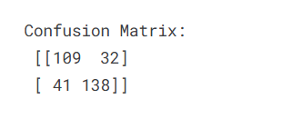
print('Accuracy:',a*100)
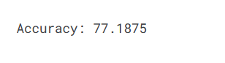
print('Precision:',p*100)

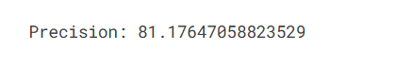
print('Recall:',r*100)

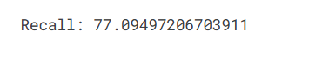

4.Visualizing Confusion matrix using seaborn
#Create space to draw the chart
fig, ax = plt.subplots(figsize=(7.5, 7.5))

plt.subplots(): Create a diagram and an axis (where the content is drawn)
figsize=(7.5, 7.5): Set the size of the chart (7.5 inches wide, 7.5 inches high)

#Show matrix below image (heatmap)
ax.matshow(c, cmap=plt.cm.Blues, alpha=0.3)

cmap=plt.cm.Blues: Use the blues palette (`Blues`). The darker the color, the higher the value.

alpha=0.3: Makes the image transparent (value from 0 to 1). `0.3` is slightly transparent, making it easier to see.

#Iterate through each row
for i in range(c.shape[0]):

range(c.shape[0]): Loop through the rows (first row is the actual value of class 0, second row is class 1).

#Iterate through each column
for j in range(c.shape[1]):
ax.text(x=j, y=i,s=c[i, j], va='center', ha='center', size='xx-large')

ax.text(x=j, y=i, s=c[i, j], va='center', ha='center', size='xx-large'): Write the values ​​(like 109, 32, 41, 138) in the correct place in each cell.

range(c.shape[1]): Loop through the number of columns (first column is class 0 prediction, second column is class 1).

va='center', ha='center': Center the text vertically and horizontally.
size='xx-large': Large font size, easy to read.

# Label the x-axis "Predictions"
plt.xlabel('Predictions', fontsize=18)

# Label the y-axis "Actuals"
plt.ylabel('Actuals', fontsize=18)

# Set a title for ‘“Confusion Matrix”
plt.title('Confusion Matrix', fontsize=18)
plt.show()

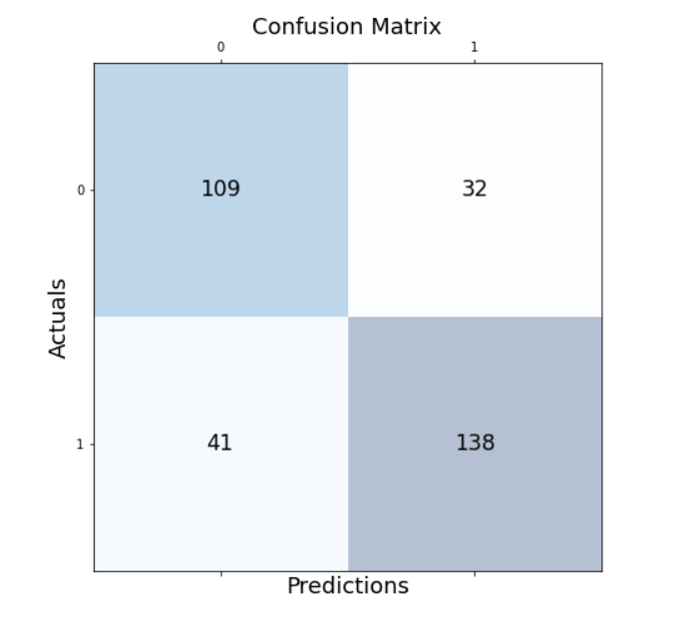

MEMBER’S CONTRIBUTION

No | Student name | Student ID | Work | Contribution
1 | Nguyễn Tú Anh |  | + Identity titles and learn more about the main topic.  +Learn information , share main ideas and work on code  + Study and learn about code | 25%
2 | Đào Thị Phương Anh | 22070895 | + Identity titles and learn more about the main topic .  +Learn information , share main ideas and work on code  + Study and learn about code | 25%
3 | Nguyễn Thái Hoài An |  | + Identity titles and learn more about the main topic .  +Learn information , share main ideas and work on code  + Study and learn about code | 25%
4 | Nguyễn Quỳnh Chi |  | + Identity titles and learn more about the main topic .  +Learn information , share main ideas and work on code  + Study and learn about code | 25%

IV. Result
In this project, we implemented a classification model for red wine quality using a dataset containing various chemical properties of wine, employing the Support Vector Machine (SVM) algorithm. The main steps included data preprocessing, exploratory data analysis (EDA), data preparation, and model building.
The key results obtained from training and testing the SVM model are as follows:
- The SVM model achieved an accuracy of 77.1875% in predicting wine quality.
- The distribution plot of wine quality showed that most of the wine samples have a quality rating between 5 and 6, representing the majority of the dataset.
- Various values of hyperparameters, such as C and kernel, were tested, and the best-performing model was selected based on accuracy.

V. Conclusion
- Overall SVR perform quite well with:
  - Accuracy: 77.1875
  - Precision: 81.17647058823529
  - Recall: 77.09497206703911
- Summary:
  - Here first we Imported Library then we loaded wine data then we moved on to check if there is any null or missing value in the dataset here this wasnt the case we had preprocessed dataset so we moved on to visulaize the correkation of the parameter present in the dataset using corr() after that we plotted it using matplotlib and we went to vidualize whole dataset using hist() to better insight of the dataset.
  - There was one minor issue : so first after we visualized data we took Quality of wine and converted it to cateogrical value (True or False) since we can say that if a wine has quality value over 5 its is a good vine otherwise its a not good wine( Here are just classifying wine based on True and False i.e if it has quality score over 5 and not on values from 3-8) so the next step to change the value of quality.
  - After that we can now split our data into training data and testing data and now we use standard scaler to standardize our both data (training as well as testing).
  - After we start to biuld oue SVM Classifier , then feed our tranining data and then we move forward to predictions.
  - After prediction are done on testing data now its time to calculate Accuracy score , Precision , Recall and Confusion matrix .

- The results indicated that the model is capable of classifying wine quality with a high level of accuracy under the given dataset.
-From this project, several key insights were drawn:
- Exploratory Data Analysis (EDA) helped us gain a better understanding of the wine quality distribution, detect outliers, and identify correlations among the chemical properties of wine.
- Data preprocessing played a crucial role in enhancing the model's performance. Steps such as outlier removal, data normalization, and feature selection had a direct impact on the model's accuracy.
- The SVM algorithm proved to be effective for classification tasks involving non-linear and high-dimensional data. However, careful tuning of hyperparameters like C, kernel, and gamma was necessary to achieve optimal performance.

